2026-RFP-0002
The project involves the repair and restoration of the concrete retaining wall surrounding the outdoor seasonal pool located at the Roblin Leisure Aquatic Centre. The goal of this project is to restore the structural integrity, safety, and appearance of the retaining wall to ensure continued safe operation of the public pool facility.
REQUEST FOR pROPOSAL
POOL RETAINING WALL PROJECT
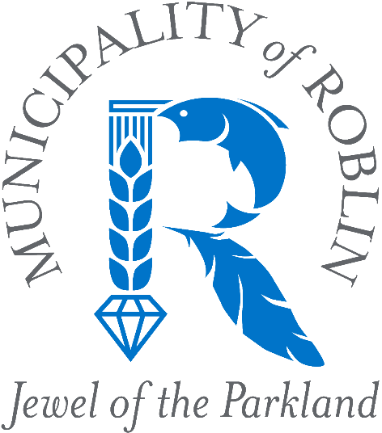
Deadline to Submit Proposal:
AUGUST 20, 2026, at 12:00pm CDT

- Invitation
  - The Municipality of Roblin invites qualified contractors to submit proposals for the repair and restoration of the concrete retaining wall surrounding the outdoor seasonal pool located at the Roblin Leisure Aquatic Centre.
    - Proponents are strongly encouraged to attend the project site prior to submitting a Proposal in order to familiarize themselves with the existing conditions and scope of the Work. Individual site visits may be arranged by appointment with Murray Schnell, Facility Manager, at 204-247-0612.
  - The objective of this project is to restore the structural integrity, safety, functionality, and appearance of the retaining wall to ensure the continued safe operation of the public pool facility.

  - The successful Proponent shall provide all labour, supervision, equipment, materials, transportation, permits, disposal, and incidentals necessary to complete the Work.

  - The Work shall include, but is not limited to:

    - Inspection and assessment of the existing retaining wall.
    - Removal and lawful disposal of deteriorated, cracked, damaged, or otherwise unsuitable concrete.
    - Repair, replacement, reinforcement, resurfacing, forming, and finishing of concrete as required to restore the retaining wall to a safe and serviceable condition.
    - Repair or replacement of any structural components directly affected by the Work.
    - Restoration of surrounding grades and drainage where disturbed during construction.
    - Protection of adjacent municipal infrastructure and pool facilities throughout construction.
    - Daily site housekeeping and final cleanup, including removal of all waste materials and construction debris.
    - Final inspection of the completed Work by the Municipality.

  - The Contractor shall complete the Work in accordance with accepted industry practices, manufacturer's recommendations, and all applicable federal, provincial, and municipal legislation, regulations, codes, and standards.
- Schedule
  - Construction shall commence in early September 2026, unless otherwise agreed to by the Municipality. The commencement date reflects the anticipated closure of the Roblin Pool for the 2026 season, which is currently expected to occur on or about August 31, 2026, but may be extended into September depending on weather conditions.
  - Substantial Completion shall be achieved no later than October 31, 2026. Time shall be of the essence.
  - Any proposed change to the schedule shall require prior written approval of the Municipality.
- Warranty
  - The Contractor shall provide a minimum one (1) year warranty covering workmanship and materials commencing on the date of Substantial Completion.
- Insurance, Liability, and Permitting
  - Prior to commencing the Work, the successful Proponent shall provide proof of Commercial General Liability Insurance with a minimum limit of Five Million Dollars ($5,000,000.00) per occurrence.
  - The Contractor shall maintain any additional insurance required by law, including Workers Compensation coverage where required under applicable legislation.
  - The Contractor shall indemnify and save harmless the Municipality of Roblin from all claims, damages, losses, liabilities, and expenses arising from the Contractor's performance of the Work.
  - The successful Contractor shall obtain all permits, approvals, inspections, and licences required to complete the Work.
  - The Contractor shall be responsible for obtaining all required utility locates prior to commencing any excavation or ground disturbance.
  - Any damage to municipal infrastructure or private property shall be reported to the Municipality immediately. The Contractor shall repair or reimburse any damage caused by the Work at no cost to the Municipality.
- Evaluation
  - Proposals will be evaluated on, but not limited to, the following:
    - Price
    - Demonstrated experience performing similar work
    - Availability of equipment and resources
    - References
    - Ability to satisfy the requirements of this Request for Proposals
  - The Municipality reserves the right to request clarification or additional information from any Proponent.
- General Conditions
  - The Municipality reserves the right to:
    - reject any or all proposals;
    - accept a proposal other than the lowest priced proposal;
    - waive minor informalities or irregularities;
    - cancel or amend this Request for Proposals at any time prior to award;
    - negotiate with the preferred Proponent where it is in the Municipality's best interest.
    - verify any information provided by a Proponent and to contact references or other sources to confirm experience, qualifications, or past performance.
    - correct obvious mathematical errors after consulting with the Proponent.
  - Submission of a proposal does not create any contractual obligation on the Municipality.
  - The successful Proponent may be required to enter into a written agreement satisfactory to the Municipality.
  - The Municipality may interview one or more Proponents or request presentations as part of the evaluation process.
  - The Municipality reserves the right to reject any Proposal that is incomplete or fails to substantially comply with the requirements of this Request for Proposals.
  - The Proponent shall disclose any actual or potential conflict of interest that may exist with respect to this procurement or any resulting Contract. Failure to disclose a conflict of interest may result in disqualification of the Proposal.
  - Proposals shall remain open for acceptance by the Municipality for a period of thirty (30) days following the closing date.
  - Any deficiencies identified during inspection shall be corrected by the Contractor within a timeframe acceptable to the Municipality at no additional cost.
  - Any interpretation of, or change to, this Request for Proposals shall be made only by written addendum issued by the Municipality. No oral representation shall be binding upon the Municipality.
  - The Municipality may suspend all or part of the Work where, in the Municipality's opinion, unsafe conditions, unacceptable workmanship, or other deficiencies exist.
  - The Contractor shall act solely as an independent contractor and nothing contained within this Request for Proposals or any resulting agreement shall be construed as creating an employer-employee relationship.

- Submission
  - The proponent shall include on their submission:
    - The Proponent shall provide a detailed lump sum price identifying the major cost components of the Work, including labour, materials, equipment, disposal, subcontractors (if applicable), taxes, and any assumptions, exclusions, allowances, contingencies, or qualifications forming part of the proposed price.
    - Brief history of the company.
    - Names and positions of key personnel assigned to the project and a summary of their relevant experience.
    - Description of experience completing similar concrete repair, retaining wall, or municipal infrastructure projects.
    - Applicable licences, certifications, and qualifications
    - Provide a minimum of three (3) references for comparable projects completed within the past five (5) years, including organization name and contact information.
    - Proof of Commercial General Liability Insurance, or confirmation that such coverage will be provided upon award of the Contract.
    - Proof of Workers Compensation coverage or confirmation that coverage is not required under applicable legislation.

  - Proposals must be submitted in a sealed envelope clearly marked "2026-RFP-0002 Submission" or by email with the subject line "2026-RFP-0002 Submission".
  - Proposals must be received no later than 12:00 p.m. CDT on Thursday, August 20, 2026. Late proposals will not be accepted.
  - Proposals shall be submitted to:
Dione Cherneski, CMMA
Chief Administrative Officer
Municipality of Roblin
125 – 1st Avenue NW
PO Box 998
Roblin, MB R0L 1P0
Email: cao@roblin.ca
7(4) Questions regarding this Request for Proposals shall be submitted in writing to the Murray Schnell, Facility Manager at rinkmanager@roblin.ca.
7(5) Any clarification or addendum issued by the Municipality shall form part of this Request for Proposals.

